**Object Oriented Design**

A class is the blueprint of an object. The implementation of the class is the object. The members of the class define the behavior of the class. The class is not visible to the world, but the object is.

Pillars of OOP –

Data Abstraction – Representing important and special features without including the background details or explanation about that feature. Data abstraction simplifies database design.

View 1

View 3

View 2

Physical View

(how data is stored)

Logical View

(what data is stored)

User Level View

Encapsulation – Wrapping data and the methods that work on data within one unit. Example, a stack class. This concept is used to hide the internal state representation of an object from the outside.

Inheritance – Ability of one class to inherit capabilities or properties of another class, aka parent class. This concept allows reuse of code whenever possible and reduce redundancy.

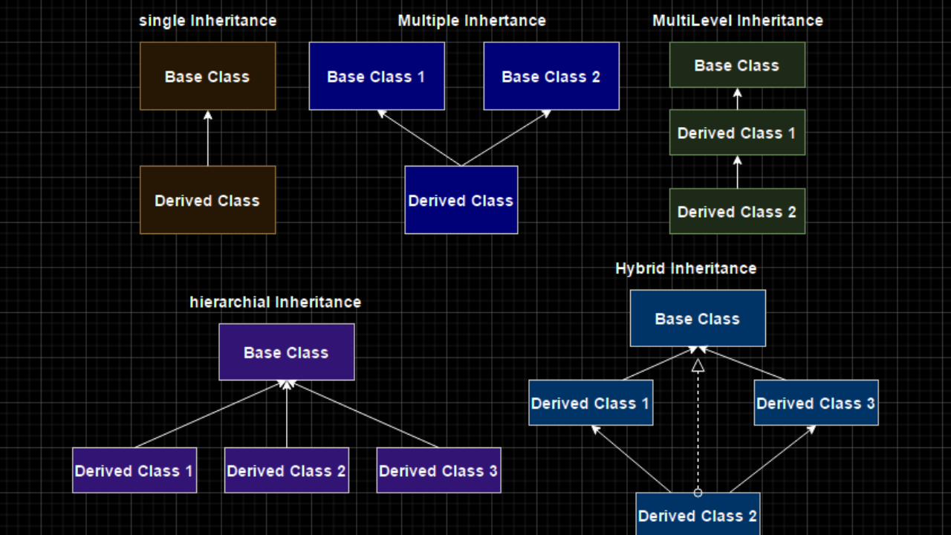

Polymorphism – Ability of data to be processed in more than one form. It allows the performance of the same task in various ways. It consists of method overloading and method overriding.

